Big Soda Echoing Big Tobacco's Tactics, Says Report on Lobbying
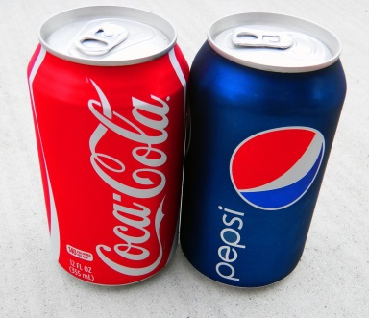
The two soft-drink companies -- either individually or together -- have backed a total of 96 national health organizations and lobbied against 29 health bills intended to reduce consumption of their products and fight obesity, the Boston University study found. The authors looked at activity from 2011 and 2015.
Advertising Age 10.10.16
http://adage.com/article/cmo-strategy/big-soda-echoing-big-tobacco-s-tactics-report/306232/?utm_source=daily_email&utm_medium=newsletter&utm_campaign=adage&ttl=1476763674?utm_visit=113450
image source:
http://2.bp.blogspot.com/-BwNd3GlSSlU/T1r5tEzFPZI/AAAAAAAAVW8/-SvybIyh5o0/s1600/Coke-and-Pepsi.jpg

