Black Journalist's Arrest Draws Outrage
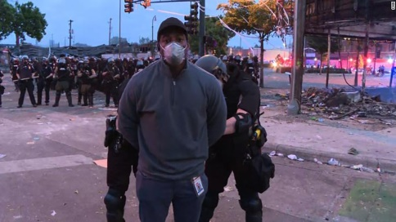
Minneapolis police arrested CNN reporter Omar Jimenez and the team with him as they covered protests over the murder of George Floyd, leading to outrage from multiple media platforms, especially as a white journalist nearby did not face arrest. The police also launched tear gas into the protesting crowds, striking Dymanh Chhoun, a photographer for CBS affiliate WCCO.
Variety online 5.29.20
https://variety.com/2020/tv/news/cnn-omar-jimenez-reaction-tv-news-journalists-1234619857/
Image credit:
https://thegrio.com/wp-content/uploads/2020/05/Omar-Jimenez.jpg

