Board Wants Age-Based Ratings For Streaming Video
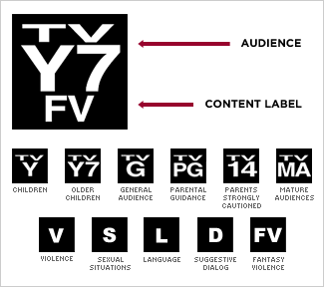
The TV Parental Guidelines Board has recommended that streaming video services adopt the age-based ratings that television shows use. Services should display ratings when viewers start videos, the board adds, and should also provide the same type of description TV ratings do.
Next TV/Broadcasting+Cable 9/28/21
https://www.nexttv.com/news/industry-board-calls-for-tv-ratings-for-streaming-services
Image credit:
http://images2.wikia.nocookie.net/__cb20130320090108/rating-system/images/b/b7/TV_Ratings.png

