Boston Celtics Jerseys Will Include a GE Advertising Patch
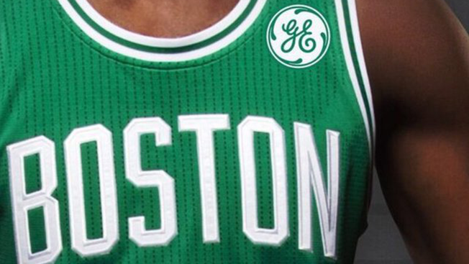
The Boston Celtics became the latest team to add an advertising patch to the jersey, announcing a partnership with General Electric. The patch will be GE's circle logo and will be rendered in white with a green background on the white jerseys and green with a white background on the green jerseys.
Business Insider 1.225.17
http://www.businessinsider.com/boston-celtics-unveil-new-jerseys-that-include-a-ge-advertising-patch-2017-1

