Boston’s First Black Female-Owned Radio Station
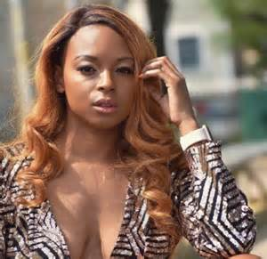
Spark FM is the first all-digital radio station in Boston owned by a black woman, catering specifically to local interests within the urban black community. It will launch April 20. Boston-based radio personality Danielle Johnson said, “I saw the need for a platform that actually caters to the demographics that are oftentimes overlooked and under-represented from the bigger names in media platforms.”
The Daily Free Press 1.21.20
https://dailyfreepress.com/2020/01/21/bostons-first-black-female-owned-radio-station-to-launch-in-april/?utm_source=Daily%20Lab%20email%20list&utm_campaign=6d85c34e78-dailylabemail3&utm_medium=email&utm_term=0_d68264fd5e-6d85c34e78-396123901

