Opinion: Brand Journalism Is Changing The Media Landscape
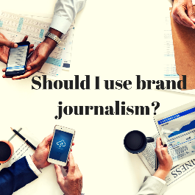
More brands are moving into the journalism field and creating their own documentaries (Formula 1), podcasts (Slack) and content platforms (TD Bank) as consumers look to brands for expertise, writes Faith Previtera, who leads the Hill-Holliday content team. "People increasingly want businesses to be engaged in doing more, saying more and providing more resources for the people they serve," writes Previtera.
Ad Age (tiered subscription model) 11.4.22
https://adage.com/article/opinion/5-ways-brands-are-transforming-future-media/2447931?adobe_mc=MCMID%3D57879159124384448554496278073193031846%7CMCORGID%3D138FFF2554E6E7220A4C98C6%2540AdobeOrg%7CTS%3D1667652811&CSAuthResp=1%3A%3A113450%3A0%3A24%3Asuccess%3A04EB26EF4089BF46312A98622086B9B4
Image credit:
http://martellpr.com/wp-content/uploads/2018/10/Should-I-use-brand-journalism_.png

