Brands Can Boost Marking With AR in 5 Ways
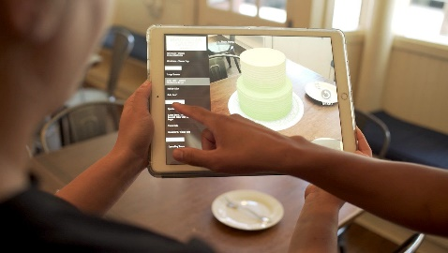
Stephanie Miles explores five ways brands are creating augmented reality offerings, including interactive advertising, gifting and "living labels." Bakeries are offering virtual pastry models, Coca-Cola is personalizing its billboards and some businesses are even setting themselves up as Pokemon Go locations.
Street Fight 2/16/21
https://streetfightmag.com/2021/02/16/how-restaurants-are-using-interactive-ar-in-2021/#.YC8DPuhKiUl
Image credit:
https://techtrends.tech/wp-content/uploads/2019/02/Tech-Trends-Kabaq-Realistic-Augmented-Reality-Menus-Alice-Bonasio-VR-Consultancy-immersive-technology-5-1200x678.jpg

