Brands, Social Media Orgs Plan to Fight Unsafe Content
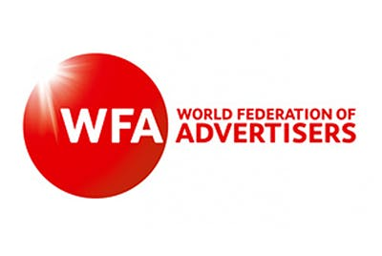
Major brands and social media companies have joined forces with the Global Alliance for Responsible Media -- which was founded by the World Federation of Advertisers in partnership with the Association of National Advertisers -- to fight harmful content with a three-pronged approach. The campaign, announced at the World Economic Forum in Davos, Switzerland, aims to define harmful content, develop measurement standards and give marketers tools to determine where their money is going.
The Drum (free registration) 1.22.20
https://www.thedrum.com/news/2020/01/22/pg-google-lego-more-unveil-plan-suffocate-harmful-content

