Broadband Access Is A Necessity For 84%
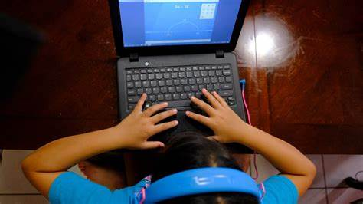
Broadband connectivity is reliable for 89% of people in an Amdocs and Dynata survey, which found that 84% of respondents think access is necessary. More speed would get extra money from 52% and reliability would open the wallets of 38%.
Telecompetitor 3.20.23
https://www.telecompetitor.com/internet-satisfaction-report-89-have-reliable-access/
Image credit:
https://angelusnews.com/wp-content/uploads/2020/06/20200611T1000-966-CNS-IN-DEPTH-BROADBAND-ACCESS-scaled-e1591896767527.jpg

