Edison: Broadcast Radio Still Tops Share Of Ear
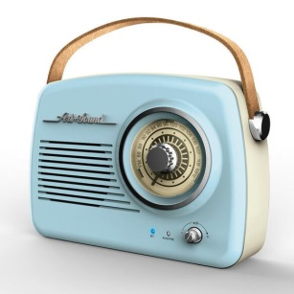
AM and FM radio accounted for the lion's share of time spent listening to ad-supported audio across all demographics last year, Edison Research's latest "Share of Ear" report indicates. Radio's share of ad-supported audiences climbed year-over-year along with podcasts, while Pandora and Spotify each saw declines.
Inside Radio (free content) 3.8.22
https://www.insideradio.com/free/am-fm-radio-maintains-its-dominance-among-ad-supported-audio/article_9ce0e4ec-9eb5-11ec-a465-d30a4c09c9d4.html
Image credit:
https://www.fye.com/dw/image/v2/BBNF_PRD/on/demandware.static/-/Sites-fye-master/default/dwea9fa3d8/fye/000/000000/fye.000000680079330156_0.jpg?sw=584

