Broadcast Radio Still Dominates In-Car Listening
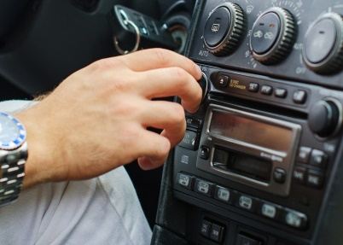
Some 81% of Americans say they tune in to radio broadcasts in their vehicles, a study by Triton Digital and Edison Research shows. Broadcast radio remains the medium of choice for in-vehicle listening, with 50% of respondents saying they used AM/FM radio most frequently.
Inside Radio (free content) 3.20.20
http://www.insideradio.com/free/despite-rising-alternatives-am-fm-remains-king-of-the-road/article_8c4ad454-6a81-11ea-acff-1f9f9c2a06a3.html
Image credit:
http://www.slate.com/content/dam/slate/articles/technology/technology/2016/06/160601_TECH_car-radio.jpg.CROP.cq5dam_web_1280_1280_jpeg.jpg

