Broadcasters Leap Into Action As Record Storm Hits
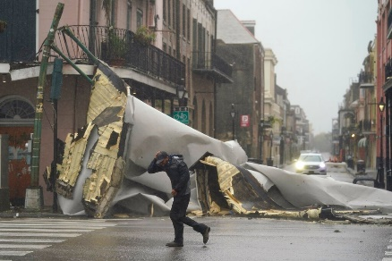
Radio and television stations in New Orleans and surrounding areas offered nonstop coverage of Hurricane Ida as the record-tying storm made landfall, knocking out power and prompting flood warnings. Many stations worked in partnership, offering simulcasts to keep audiences informed about evacuation orders ahead of the storm and updates as it hit.
All Access Music Group 8.30.21
https://www.allaccess.com/net-news/archive/story/210712/hurricane-ida-makes-landfall-as-a-category-4-storm
Image credit:
https://knews.uk/wp-content/uploads/2021/08/Winds-gale-gales-from-Hurricane-Ida-Lash-Louisiana.jpg

