Broadcasters, Theaters Will Get Relief Under New Bill
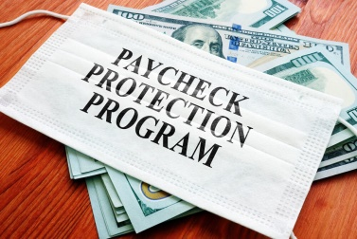
The latest pandemic relief bill will expand Paycheck Protection Program eligibility to local broadcasters and newspapers. The legislation, which was introduced on Dec. 20, also earmarks $15 billion to assist live entertainment venues, cultural institutions and independent cinemas.
The Hollywood Reporter 12.20.20
https://www.hollywoodreporter.com/news/new-covid-relief-bill-earmarks-15b-for-movie-theaters-and-live-event-venues
Image credit:
https://www.mcb.cpa/wp-content/uploads/2020/05/Paycheck-Protection-Program.jpg

