Broadcasters, Newspapers Seek Additional Federal Support
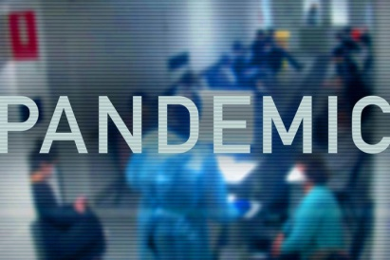
Members of the National Association of Broadcasters, the News Media Alliance, America's Newspapers and the National Newspaper Association are asking federal lawmakers to grant local news organizations additional crisis funding, warning that current restrictions bar some organizations from obtaining much-needed support. Amador Bustos, president of Bustos Media, says his organization could be forced to close stations or leave some markets if it doesn't receive federal relief.
Axios 4.9.20
https://www.axios.com/local-media-congress-coronavirus-relief-eb296fb0-5924-484a-ae29-3ac4e8d593f7.html
Image credit:
https://www.abc.net.au/news/image/12103602-3x2-940x627.jpg

