Broadcasters Take Action as Tornadoes Hit South
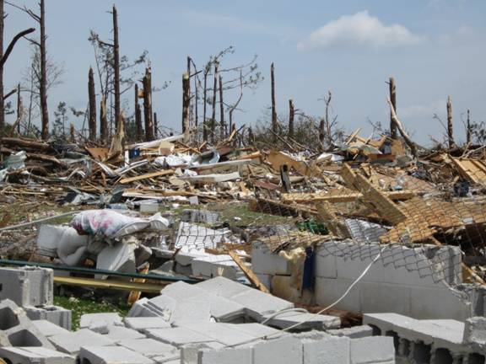
Broadcasters in the South used their social media, radio and TV outlets over the weekend to get the word out about impending severe weather -- two deadly tornadoes that ripped through Alabama, Georgia, Florida and South Carolina on Sunday and claimed the lives of more than 20 victims. Alabama broadcasters will be raising money and collecting item donations Wednesday for communities that were devastated by the disasters.
All Access Music Group 3/4/19
https://www.allaccess.com/net-news/archive/story/184505/dozens-dead-as-violent-tornadoes-hit-the-south
Image credit:
http://www.drroyspencer.com/wp-content/uploads/Fords-Chapel-AL-tornado-3.jpg

