Cable Companies Expected to Add 1.6M New Mobile Customers
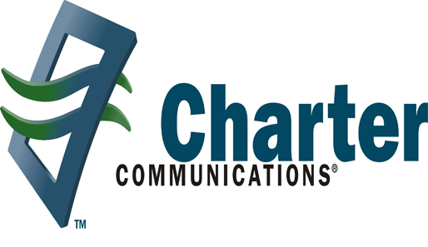
Morgan Stanley is projecting that 1.6 million people will sign up for mobile service in 2019 via cable companies Charter, Comcast or Altice. Comcast, which unveiled its Xfinity Mobile service in 2017, reported the biggest growth in business, with 1 million mobile lines at the end of its most recent quarter.
FierceWireless 12/13/18
https://www.fiercewireless.com/wireless/cable-industry-to-add-1-6m-mobile-customers-2019-analysts-predict

