Cable Industry Avoids Drama with Recent Round of Retrans, Carriage Pacts
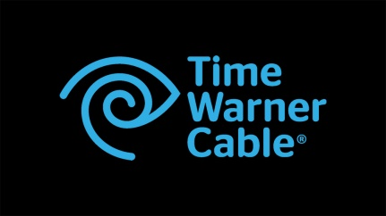
Cable providers and programmers finished 2015 on a quietly productive note by signing new retransmission consent deals and carriage agreements with little or no drama. On the retrans front, Charter Communications, Time Warner Cable and Cablevision had an additional incentive to avoid service disruptions due to pending mergers.
Multichannel News 1/11/15
http://www.multichannel.com/all-s-quiet-carriage-front-year-end-deals-get-done/396411

