Cable's Mobile Subscriber Count Nears 5M
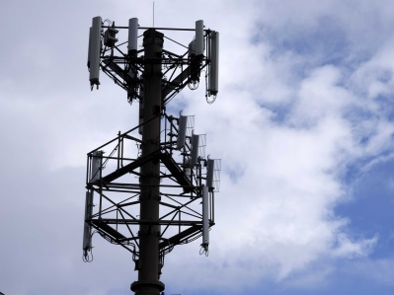
Charter Communications, Comcast and Altice USA, combined, now provide mobile service to nearly 5 million people. Comcast and Charter both use Verizon's network to offer the service, and have recently purchased Citizens Broadband Radio Service spectrum.
Telecompetitor 11.5.20
https://www.telecompetitor.com/cable-company-mobile-services-make-steady-progress-approaching-5-million-subs/
Image credit:
https://i.insider.com/5407396feab8ea5522fded2e

