Cable Subscriptions Fell by 705,000 Over the Past Year
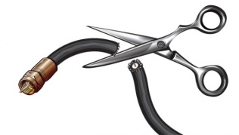
Cord-cutting is becoming more common, that much is clear. The latest quarterly pay TV subscriber numbers show people shed subscriptions 12 times faster over the past year than they had the prior year. 705,000 people dropped their subscriptions to the top eight providers, including Comcast, DirecTV and Charter, in the 12 months ended in June. That’s compared to 59,000 during the 12-month period that ended in June 2015.
MediaLife 8.12.16
http://www.medialifemagazine.com/ouch-girm-news-cord-cutting/

