Cable TV Viewing Share Increases In June
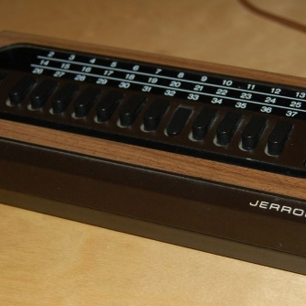
Cable networks led television viewing during June, claiming 40% of the total time people spent watching, Nielsen reported. This was an increase of one percentage point from May, and streaming platforms' share grew the same amount.
The Hollywood Reporter 7.15.21
https://www.hollywoodreporter.com/tv/tv-news/streaming-cable-grow-june-tv-usage-rankings-1234982811/
Image credit:
https://i.pinimg.com/originals/d3/6d/34/d36d349467cc0a79999d5651a7d9d91d.jpg

