Cablevision is Gaining Subscribers with Lower-Cost Offerings
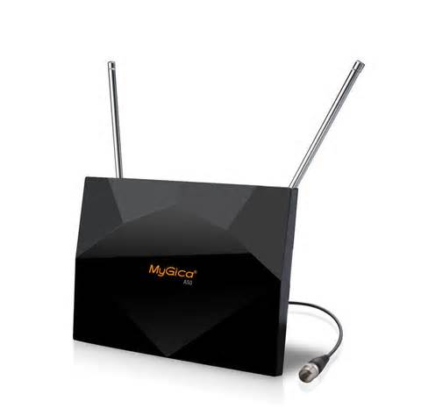
Cablevision's broadband packages with digital TV antennas are drawing new "affluent customers who just don't want to pay for TV they don't watch" and others who were not already subscribing to the company's services, said Kristin Dolan, Cablevision's chief operating officer. However, most of Cablevision's new customers choose one of its triple-play bundles, Dolan said at an investors conference.
FierceCable 9/10/15
http://www.fiercecable.com/story/kristin-dolan-cord-cutter-broadband-packages-bringing-new-customers-not-can/2015-09-10

