Calif. Approves Digital Privacy Proposal
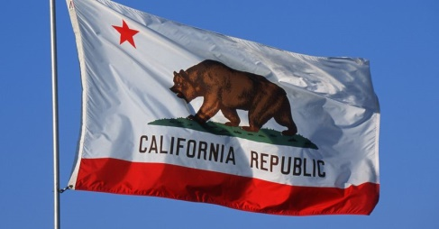
Lawmakers in California have approved a privacy bill that allows people to prohibit companies from selling their personal data, including browsing behavior, as well as giving them the right to demand that companies delete their information. The legislation will come into effect in January 2020, which will give the attorney general time to "clarify a number of ambiguous and conflicting provisions in the legislation," said the Association of National Advertisers.
MediaPost Communications 6/28/17
https://www.mediapost.com/publications/article/321512/california-passes-broad-online-privacy-bill.html
Image credit:
https://us-east-1.tchyn.io/snopes-production/uploads/2017/05/california_flag_fb.jpg?resize=865,452

