Car Windows Will Soon be Screens for Content
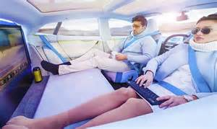
Autonomous vehicles are poised to revolutionize marketing, and luxury automakers will focus on selling their cars' internal entertainment features rather than spotlighting performance, a Forrester study finds. The report also predicts that car windows will become screens for publishing and ad content.
MediaPost Communications 8/1/17
https://www.mediapost.com/publications/article/305066/autonomous-vehicles-projected-to-drive-in-car-adve.html
Image credit:
https://www.bing.com/images/search?view=detailV2&ccid=ccivko6T&id=3CF016073A50D2300BC7B77D4FC6BF6A9996E8E3&thid=OIP.ccivko6TxPG-ZklIJezHpQEsCz&q=ads+on+windshield+of+autonoumos+car&simid=608007391814550143&selectedIndex=203&ajaxhist=0

