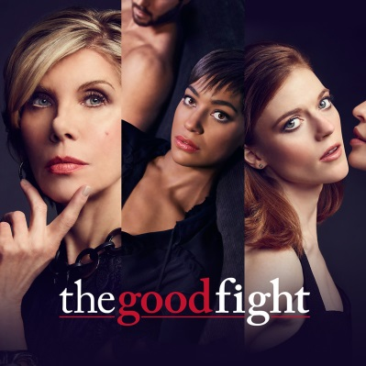
CBS Censors a ‘Good Fight’ Segment. Its Topic Was Chinese Censorship.
A theme of last Thursday’s episode was American companies that want to do business in China and the pressures they face to appease Chinese government censors. An animated short was created on that same theme.
The New York Times 5.7.19
https://www.nytimes.com/2019/05/07/arts/television/cbs-good-fight-chinese-censorship.html?action=click&module=News&pgtype=Homepage&utm_source=Listrak&utm_medium=Email&utm_term=CBS+Censors+%26%23039%3bGood+Fight%26%23039%3b+Segment+On+Chinese+Censorship&utm_campaign=Outcome+Selling+Could+Be+TV%27s+Next+Big+Thing
Image credit:
https://televisionpromos.com/wp-content/uploads/2016/12/The-Good-Fight-CBS-All-Access-TV-series.jpg

