CBS Debuts Ad-Free All Access Streaming Service
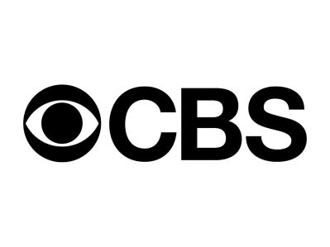
CBS has introduced an ad-free option for its All Access on-demand service. The subscription service is priced at $9.99per month and will eliminate almost all advertising, with the exception of "promotional interruptions" in select series.
Deadline.com 8/31/16
http://deadline.com/2016/08/cbs-all-access-introduces-ad-free-on-demand-option-1201811555/

