CBS Goes Dark On DirecTV, DirecTV Now, U-Verse
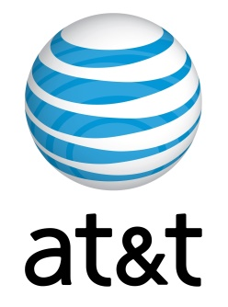
Unable to reach an agreement with CBS on programming fees, AT&T early Saturday morning dropped CBS's broadcast and cable programming from its TV distribution services -- DirecTV, DirecTV Now and U-Verse, according to CBS. “While CBS has made every effort to avoid this blackout, we won’t agree to terms that undervalue our hit programming enjoyed by nearly 240 million viewers across all dayparts last season."
TVNewsCheck 7.22.19
https://tvnewscheck.com/article/top-news/237048/cbs-goes-dark-on-directv-directv-now-u-verse/?utm_source=Listrak&utm_medium=Email&utm_term=CBS+Goes+Dark+On+DirecTV%2c+DirecTV+Now%2c+U-Verse&utm_campaign=CBS+Goes+Dark+On+DirecTV%2c+DirecTV+Now%2c+U-Verse

