It’s True: CBS Radio is on the Block
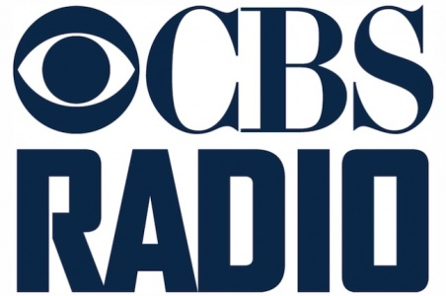
“We will begin to explore strategic options,” Les Moonves said during a talk at CBS investor day. “We will be prudent and judicious. We will take our time to make sure that we do it right.” CBS Radio ranks No. 4 in the number of stations it owns, 117 across 26 markets, but No. 2 in station revenues, behind only iHeart Media.
MediaLife 3.16.16
http://www.medialifemagazine.com/its-true-cbs-radio-is-on-the-block/

