CBS Snaps Up Bulk of Former Westwood Stations
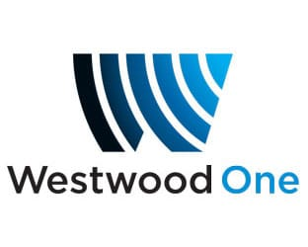
CBS News has signed affiliation agreements with 148 stations formerly owned by Westwood One News following Cumulus Media's announcement it would shut down Westwood. Fox News Audio has picked up 56 of the remaining stations.
Radio and Television Business Report 9.3.20
https://www.rbr.com/cbs-fox-pick-up-some-former-wwo-news-affiliates/

