China Tightens Grip on Foreign Press
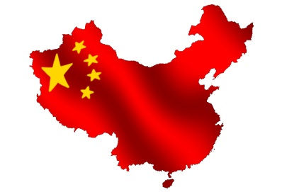
The Ministry of Industry and Information Technology’s new rules could, if they were enforced as written, essentially shut down China as a market for foreign news outlets, publishers, gaming companies, information providers, and entertainment companies.
Poynter.org 2.24.16
http://www.poynter.org/2016/china-tightens-grip-on-foreign-press-but-will-anyone-feel-the-squeeze/397693/?utm_source=API+Need+to+Know+newsletter&utm_campaign=600c1e1a6c-Need_to_Know_February_25_20162_25_2016&utm_medium=email&utm_term=0_e3bf78af04-600c1e1a6c-31697553

