Chipotle's Recipe for Its Turnaround: Digital Marketing
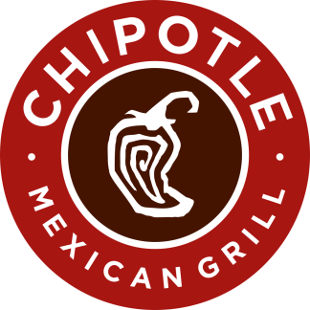
During an Advertising Week talk, Chipotle Chief Marketing Officer Chris Brandt credited digital marketing successes with helping the fast-food purveyor overcome its food safety issues and boost revenue by $1.2 billion revenue in one quarter. The brand refresh included a more centralized marketing model, TV, digital and social spots using content highlighting employee routines, influencer challenges on TikTok and Venmo and Twitter promotions.
Marketing Dive 9/25/19
https://www.marketingdive.com/news/how-chipotle-saved-its-brand-by-embracing-a-centralized-digital-marketing-s/563655/

