Web Inventor: Closing Digital Divide Must Be Top Priority
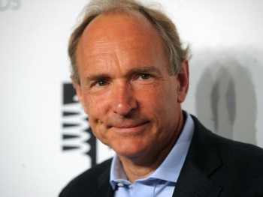
World Wide Web inventor Tim Berners-Lee said Thursday the COVID-19 pandemic demonstrates “the gross inequality” of a world where almost half the population is unable to connect to the internet. He told a high-level U.N. meeting “our number one focus must be to close the digital divide.”
TVNewsCheck 6.12.20
https://tvnewscheck.com/article/more-news/250080/web-inventor-closing-digital-divide-must-be-top-priority/?utm_source=Listrak&utm_medium=Email&utm_term=Web+Inventor%3a+Closing+Digital+Divide+Must+Be+Top+Priority&utm_campaign=Amid+Protestors%2c+Police+And+Looters%2c+A+Fox+News+Reporter+Finds+Moments+Of+Authenticity
Image credit:
https://www.bing.com/images/search?view=detailV2&ccid=IynvGuFc&id=A43A04D26A25C67FCEBC2F2335DAF761C21E99D1&thid=OIP.IynvGuFcEaYuTvEv3LPm3QHaFj&mediaurl=https%3A%2F%2Famp.businessinsider.com%2Fimages%2F5bdc7d0d110d4c6e306b5693-750-563.jpg&exph=563&expw=750&q=tim+berners+lee&simid=608013596259519048&ck=4792F9E85180F32062A42EED12DF05C8&selectedindex=4&ajaxhist=0&vt=3&sim=8&cal=0.28057098&cab=0.78254694&cat=0.26477998&car=0.66826355

