Clubhouse Opens To All Users; Launches Brand Refresh
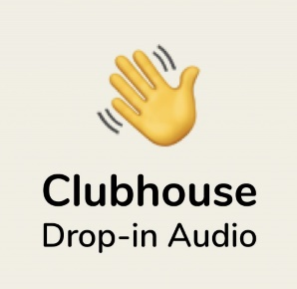
The Clubhouse audio platform has moved out of beta to open its service to all users, and unveiled an updated logo and a refreshed website. Clubhouse reports that 500,000 rooms are added daily, and average listening time is more than one hour daily, while Android users have downloaded the app 10 million times since being able to in May.
Adweek 7/21/21
https://www.adweek.com/media/clubhouse-drops-invite-only-model-reveals-new-logo-app-icon/

