Coalition for Better Ads Tackles Ad Blocking with Global Standards
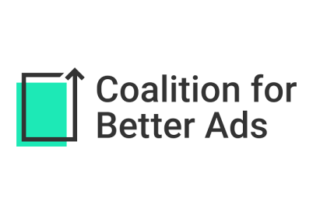
The Coalition for Better Ads has created worldwide standards to tackle ad blocking by identifying 18 irritating ad formats that advertisers should avoid, such as autoplay videos, pop-ups and mobile prestitial ads.
Reuters 3/22/17
http://in.reuters.com/article/advertising-standards-idINKBN16T0OL?il=0

