College Radio Society Aims To Sustain Magic For Alumni
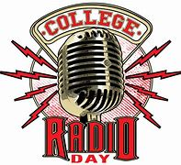
The College Radio Society is working to highlight the value of school stations to the public, reunite alumni and maintain the magic and memories that college radio has created for many. Volunteers lead the organization, which is working on a book and documentary about the history of college radio.
Radio World 3/28/23
https://www.radioworld.com/columns-and-views/guest-commentaries/college-radio-history-the-race-is-on?utm_term=A25693A1-51B6-4112-BDE4-56BD420E983F&utm_campaign=45863C53-9E40-4489-97A3-CC1A29EF491D&utm_medium=email&utm_content=CB12C5C1-E6CA-4973-A500-5F8AD9553C89&utm_source=SmartBrief
Image credit:
https://assets2-my.umbc.edu/system/shared/thumbnails/events/000/053/782/d9976d1ee795080454363a18e112110c/xxlarge.jpg?1507233602

