Comcast Acquires Municipal Broadband Systems In Mass.
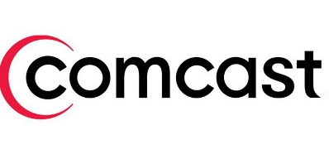
Comcast has bought a pair of small municipal broadband systems in Braintree and Russell, Mass., for an undisclosed price, as the towns say it would be too costly to upgrade their networks by themselves. The cable company will gain roughly 2,500 subscribers from Braintree Electric Light Department and an unstated number from Russell Municipal Cable TV.
Light Reading 12/2/21
https://www.lightreading.com/cable-tech/comcast-travels-manda-path-in-massachusetts-/d/d-id/773856?

