Comcast Deploys First Private Wireless Network In Philly
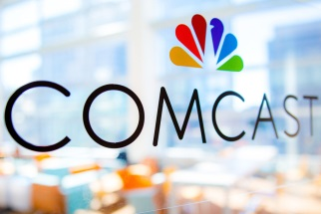
Comcast Business will activate 4G and 5G at Philadelphia's Wells Fargo Center early this year, the first private network the company is providing at scale. The project will leverage spectrum that Comcast has acquired in the Citizens Broadband Radio Service band and use Digital Automation Cloud technology from Nokia.
FierceWireless 1.21.22
https://www.fiercewireless.com/private-wireless/comcast-enters-private-wireless-business-lights-wells-fargo-center

