Comcast Eyes $2B Commitment to Peacock's Initial 2 Years
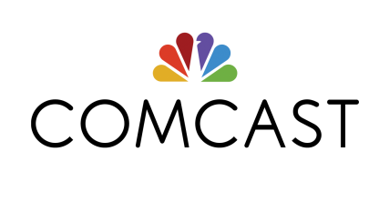
Michael Cavanagh, Comcast's chief financial officer, told an analyst conference on Monday that the cable company will pour $2 billion into its Peacock streaming platform during the two years following its April 2020 introduction, and remain in the red for five years. Ad-supported Peacock will be free to Comcast subscribers and possibly other cable customers, though Cavanagh didn't reveal details.
Variety online 12/9/19
https://variety.com/2019/digital/news/comcast-peacock-2-billion-streaming-service-1203429809/

