Comcast: No Plans To Acquire More Assets
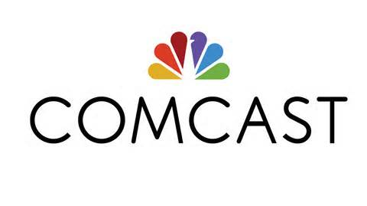
"We love the company that we have," said Brian Roberts, CEO of Comcast, trying to dispel acquisition rumors in a recent conference call. Peacock brought in more than $1 billion for the company last quarter, and overall numbers caused Comcast's stock to rise.
Deadline Hollywood 1.25.24
https://deadline.com/2024/01/comcast-brian-roberts-peacock-epic-universe-ad-market-deal-speculation-1235804521/

