Comcast Plans $15-a-month Streaming TV Service
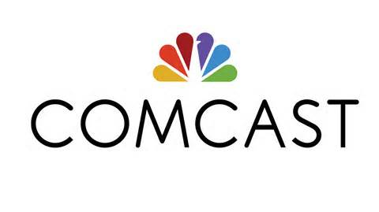
Comcast is planning a $15-a-month streaming service aimed at younger consumers that will offer several broadcast networks, as well as HBO, and will let subscribers use some TV Everywhere applications and a cloud DVR service. Stream, an add-on to broadband service that is meant for PCs, laptops and mobile devices, will begin a trial by the end of summer in Boston, followed by Chicago and Seattle. The service's nationwide rollout is slated for early next year.
The Verge 7/12/15
http://www.theverge.com/2015/7/12/8942313/comcast-stream-streaming-tv-xfinity-subscribers

