Comcast Promises $1B Investment in Internet Essentials
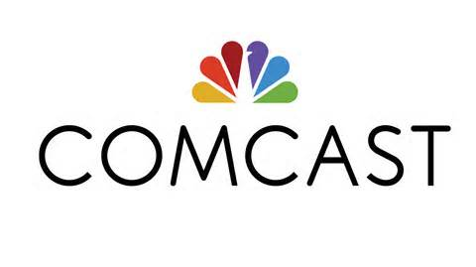
Comcast has promised to spend $1 billion during the upcoming 10 years to support broadband services for low-income households in its coverage areas as part of its ongoing Internet Essentials program. Some of the funds will subsidize Lift Zone, an initiative that adds safe spaces with internet connections in community centers.
Next TV/Multichannel News 3/24/21
https://www.nexttv.com/news/comcast-pledges-to-invest-dollar1-billion-over-10-years-in-internet-essentials

