Comcast Seeks to Harness Trove of TV Data
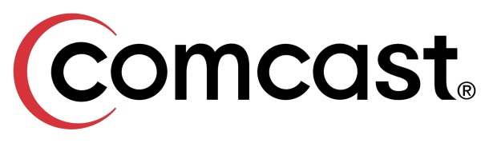
Comcast is in talks with audience-measurement firms and television networks, including Walt Disney Co.’s ESPN, Time Warner Inc.’s Turner Broadcasting and Discovery Communications Inc., about licensing its data to them. It already has a deal with its own NBCUniversal unit and at least one other media company, said people familiar with the deals.
The Wall Street Journal 10.20.15
http://www.wsj.com/article_email/comcast-seeks-to-harness-trove-of-tv-data-1445333401-lMyQjAxMTE1NTIwMDgyMjA2Wj

