Comcast Sees 80% Rise in Demand for Streaming Content
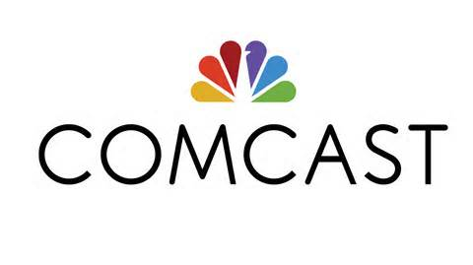
Demand for streaming services content at Comcast has risen by 80% from the same period in 2019, the cable company's Rebecca Heap says, calling the aggregation of streaming programming "critical to our strategy." Over-the-top video has proved especially important to Comcast's broadband-based Flex platform.
FierceVideo 11.9.20
https://www.fiercevideo.com/video/comcast-says-demand-for-ott-content-up-80-its-platform

