Comcast Tests Hollowcore Fiber For Speeds Up To 400 Gbps
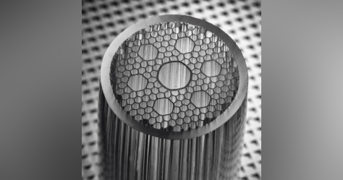
Data transmitted over hollowcore fibers reached speeds of between 10 and 400 gigabits per second in a Comcast test when mixed with traditional fiber. The technology, which delivers light via air-filled channels, also provides lower latencies.
Light Reading 4.20.22
https://www.lightreading.com/cable-tech/comcast-touts-blistering-speeds-low-latencies-with-hollowcore-fiber-/d/d-id/776891
Image credit:
https://img.cablinginstall.com/files/base/ebm/cim/image/2020/03/Hollow_Core_Preform_2___squ.5e70ea61bb2ae.png?auto=format&fit=fill&fill=blur&w=1200&h=630

