Comcast Will Help Theaters Stream Live Events
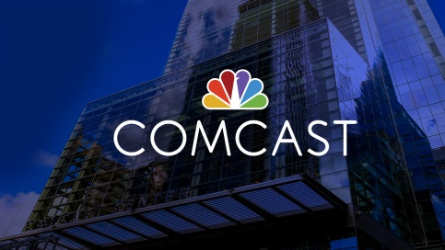
Comcast Business will provide gigabit-speed internet access to 65 movie theaters under a partnership with NetLevel that will allow the entertainment distributor to stream special events such as concerts, esports tournaments and live sports, the companies announced. They predict that NetLevel will be able to expand to roughly 600 theaters within a year and more than 6,000 by 2022 under the new arrangement.
Telecompetitor 11/5/19
https://www.telecompetitor.com/comcast-gigabit-ethernet-enables-movie-theater-transformation/

