Comcast Wins Sky Auction for $39B
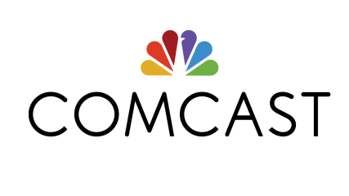
Comcast edged out Fox on Saturday to win the auction for Sky at $39 billion. Comcast must now prove to its shareholders that there will be a return on this hefty investment, Stu Woo and Shalini Ramachandran write.
CNBC 9/24/18
https://www.cnbc.com/2018/09/24/sky-to-accept-comcast-offer-immediately.html

