Comcast's Xfinity Mobile Grabbing Customers Across the Board
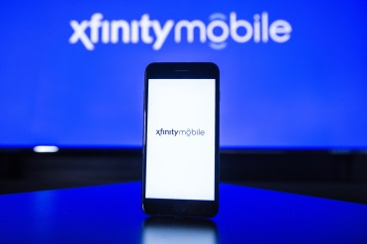
Comcast's Xfinity Mobile service is luring customers away from all major wireless providers, and the company's quad play bundle is "firmly rooted," a Market Strategies International study has found. The study found that 27% of customers who switched to Xfinity Mobile were previously with Verizon.
Telecompetitor 5/2/18
http://www.telecompetitor.com/report-declares-comcast-quad-play-firmly-rooted-with-verizon-being-the-biggest-loser/

