The Future Of Connected Devices
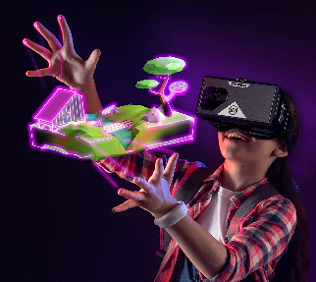
Smartphones will gain a few competitors in the next several years. As metaverse tools and wearables like virtual reality (VR) headsets become more commonplace, they will cause growth to slow for everyday devices like smartphones. These new devices may begin to compete for time spent toward the end of our forecast period in 2024.
6.10.22
https://www.emarketer.com/content/future-of-connected-devices?ecid=NL1001&utm_campaign=eDaily+weekender+6.19.2022+CORE&utm_medium=email&utm_source=Triggermail&utm_term=eMarketer+Daily+Week+in+Review+CORE%2fEMEA
Image credit:
https://www.vrheadsetonlineshop.com/wp-content/uploads/2020/02/Merge-VR-Headset-Augmented-Reality-and-Virtual-Reality-Headset-Play-Educational-Games-and-watch-360-Degree-Videos-STEM-Tool-for-Classroom-and-Home.jpg

