Connected TV Accounts for 27% of Video Impressions
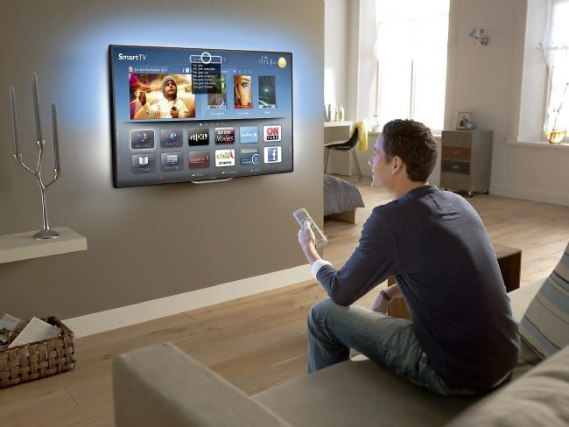
Connected TV ad impressions have spiked 106% since 2016, and connected TV now takes a 27% share of video volume, Innovid reports. The company also reports that the number of advertisers using connected TV rose 30% from 2016 to last year.
Marketing Land 9/17/18
https://marketingland.com/report-connected-tv-impressions-have-grown-106-percent-since-2016-248145
Image credit:
https://i1.wp.com/www.broadbandtvnews.com/wp-content/uploads/2013/03/Philips-smart-TV.jpg?ssl=1

