Connected TV Usage Expands Across All Generations
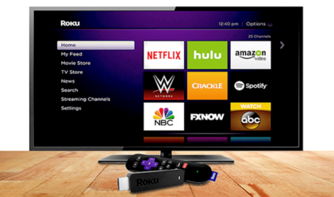
About two-thirds of the US population is monthly connected TV (CTV) users. Young people are more likely to use CTV than older people. Four in 10 US senior citizens are CTV users—whereas CTV usage is about double that, more than 80%, among those ages 25 to 54.
eMarketer 11.19.21
https://www.emarketer.com/content/ctv-usage-expands-across-all-generations?ecid=NL1001
Image credit:
https://www.notebookcheck.net/fileadmin/Notebooks/News/_nc3/smarttv2.jpg

