Consumer Reports' New App Aims To Pry Back Information
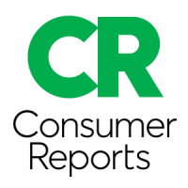
Consumer Reports is rolling out a new app to protect personal information -- Permission Slip, which does the heavy lifting of filing appeals with companies. The process involves surrendering some information to Consumer Reports, a nonprofit, but its privacy policy is legally binding, writes Thomas Germain.
Gizmodo 10.3.23
https://gizmodo.com/new-permission-slip-app-deletes-company-data-1850895021

